

Machine Learning-Music Recommendation

Progress Report

| Roll No. | Name of the Student | Name of the Program |
| --- | --- | --- |
| AU1940142 | Shail | ML |
| AU1940267 | Sahil | ML |
| AU1940034 | Varun | ML |

**Dimensions reduced**

The reductions in scale were performed in the previous week. This week we used two dimensionality reduction techniques to see which one would be better for our dataset. We explored TSNE and PCA.

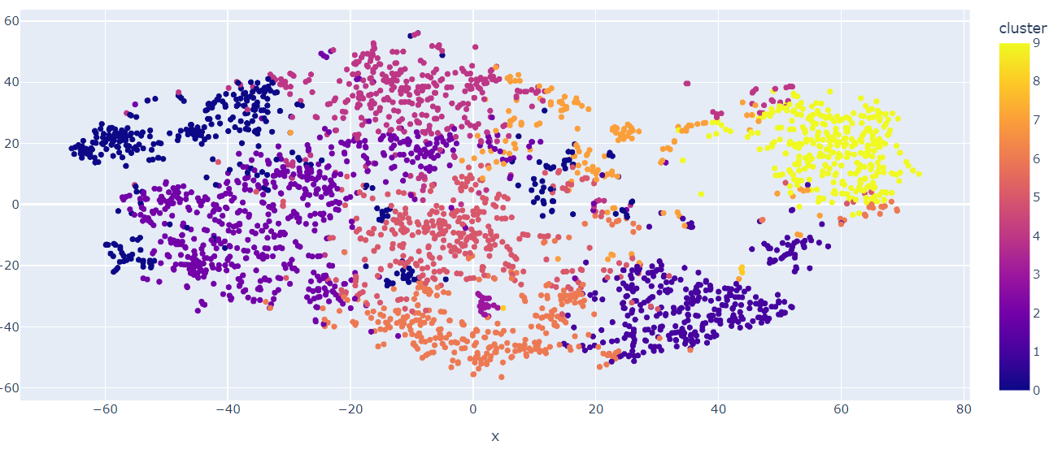

The genres were created using the genre dataset. The genres were based on the features of the song as described before (liveness, loudness, acousticness etc). The then generated genres were used to cluster the songs of a similar genre together as seen in the above picture.

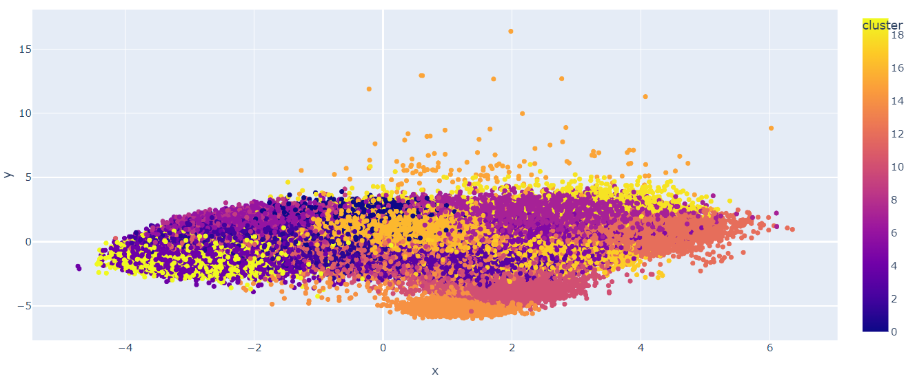

This image corresponds to dimensionality reduction by the PCA method. As clearly visible PCA does a poor job at being able to separate the data in order for the KNN to be performing boundary separation. For this reason we will be working with T-SNE for this spotify dataset.

**Future work**

The next week we will be developing a baseline KNN model and deciding upon how the UI/UX we will be able to offer to the user.